# About the application

This application is created to update Tekla models from Tekla Model Sharing.

Particularly the app is useful if you have to supervise plenty of sharing models. It helps to update all models during breaktime and have all updated models by start of your working day.

# Instruction to build

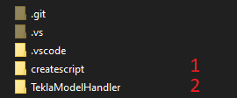

1. Createscript folder.  
   This is a folder with a code to be built for the main application. It is recommended to name the exe file as it is show below (see A.3. in Instruction to setup)

1. TeklaModelHandler folder.  
   This is a folder with a code to be built for the additional application. Before building you should set up Tekla API from Nuget package manager with Tekla version which you need. For now the main app supports only Tekla 2019 and Tekla 2020 versions.  
   After setting up Tekla version build the app and rename the exe file as it is shown below (see A.3 and A.4 in Instruction setup)

# Instruction to setup

1. Place the next files in a specific folder:

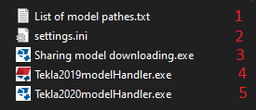

1. **List of model pathes.txt**

This file contains all model paths to be downloaded.

Tekla versions and model paths must be set and separated by comma.

Ex.:  
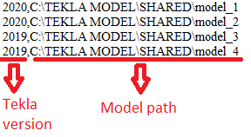

1. **Settings.ini**This file contains the settings for launching Tekla with specific initialization settings.

*XS_TEKLA(xxxx)_PATH* – the path to launch Tekla exe file.

*XS_TEKLA(xxxx)_BYPASS_PATH* – the path to set initialization settings.  
Ex.:

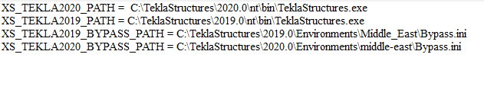

1. **Sharing model downloading.exe**The main file to start downloading.
2. **Tekla2019modelHandler.exe**The additional file for the downloading which can handle Tekla 2019 models. Do not launch it directly.
3. **Tekla2020modelHandler.exe**The additional file for the downloading which can handle Tekla 2020 models. Do not launch it directly.
4. The next file (Bypass.ini) must be adjusted according to which Tekla environment, role and license will be used. The file should be placed in a specific folder and its path must be mentioned in settings.ini file (see A.2.)



Ex.:

# Instruction to use

1. Launch **Sharing model downloading.exe file**
2. Set time limit for Tekla model opening. After this time downloading will be started.  
   If you have large models it may be require more time to be open.

1. Press **GET started** button. The application will start working opening, downloading, saving, closing specified models one by one.
2. During the application work, **log.txt** file will be created reflecting all the information about the downloading.

